**Paper Name:** Multi-channel EEG recordings during a sustained-attention driving task

**Reference Link:** <https://www.nature.com/articles/s41597-019-0027-4>

**Methods:**

**Participants:**

* The study involved 27 voluntary participants aged 22–28 with normal or corrected-to-normal vision.
* Participants underwent a 90-minute sustained-attention driving task in a virtual reality (VR) simulator.
* Recruitment was from students and staff of the National Chiao Tung University, Taiwan.

**Experimental Setup:**

* The VR driving environment featured a dynamic driving simulator mounted on a six-degree-of-freedom Stewart motion platform.
* Six highway scenes were projected for a nearly complete 360° visual field.
* Participants drove a simulated Ford Probe on a straight four-lane divided highway without traffic.
* Event-related lane-departure paradigm implemented in the VR driving simulator.
* Participants instructed to keep the car centered; lane-departure events induced randomly.
* Continuous 90-minute driving task with events, including deviation onset, response onset, and response offset.

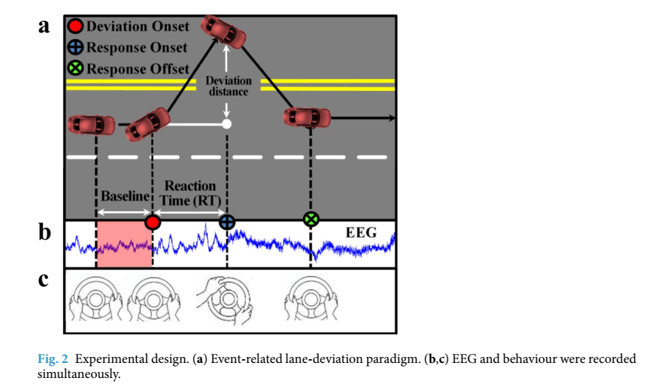

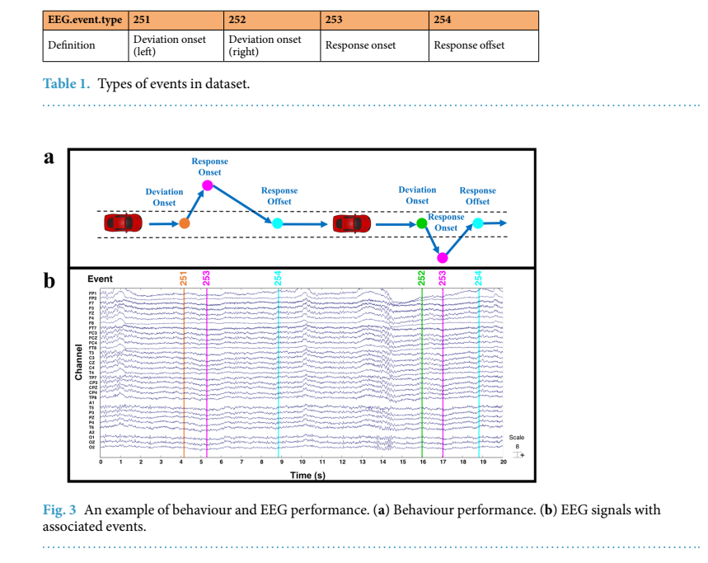

**EEG Data Acquisition:**

* 32-channel electroencephalography (EEG) signals recorded simultaneously with vehicle position.
* EEG cap with Ag/AgCl electrodes placed based on a modified international 10–20 system.
* Signals recorded using Scan SynAmps2 Express system, digitized at 500 Hz.

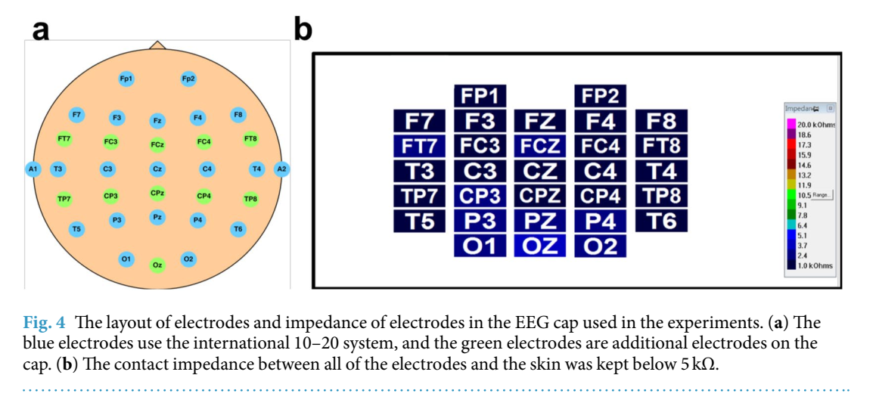

**Data Description:**

**EEG Signals:**

* Recorded using a 32-channel EEG system, including electrodes placed on the mastoid bones.
* Signals digitized at 500 Hz, saved as .cnt files, and made available in both raw and pre-processed versions.

**Event Types:**

* Events classified as deviation onset (left and right), response onset, and response offset.
* EEG event types marked with corresponding numerical codes (251, 252, 253, 254).

**Participants and Sessions:**

* Involvement of 27 participants with a total of 62 sessions.
* Each participant contributed varying numbers of sessions, totaling 81576 events across all participants.

**Validation:**

* Behavioral validation ensured participant suitability through observation of facial features and monitoring responses to lane-departure events.
* EEG validation involved pre-processing steps, including bandpass filters and artifact rejection, to ensure data quality.

**Pre-processed Datasets:**

**Steps in Pre-processing:**

1. **Bandpass Filtering:**
   * Raw EEG signals subjected to bandpass filtering to retain frequencies between 1 Hz and 50 Hz.
   * A finite impulse response (FIR) filter applied with a high-pass cutoff at 1 Hz and a low-pass cutoff at 50 Hz.
2. **Artifact Rejection:**
   * Manual removal of apparent eye blink contamination through visual inspection.
   * Automatic Artifact Removal (AAR) plug-in for EEGLAB used to correct ocular and muscular artifacts.

**Data Format and Structure:**

* **File Format:**
  + Pre-processed datasets saved in EEGLAB (.set) format.
  + The format allows for compatibility with EEGLAB toolbox functions and facilitates further analysis.
* **Contents:**
  + Each pre-processed dataset includes 32 EEG signals corresponding to electrode placements and one signal for vehicle position.
  + Event types (deviation onset, response onset, response offset) marked with numerical codes included in the dataset.

**Paper Name:** A Compact and Interpretable Convolutional Neural Network for Cross-Subject Driver Drowsiness Detection from Single Channel EEG

Reference Link: <https://arxiv.org/abs/2106.00613>

**Dataset Description:**

* An EEG dataset released by Cao et al. in 2019 was utilized.
* The dataset comprises 62 EEG datasets from 27 subjects (aged 22 to 28) collected during 2005–2012.
* Participants were students or staff from the National Chiao Tung University.
* The EEG data was collected during a sustained-attention driving task in a simulated VR driving simulator.
* Lane-departure events were introduced randomly, and participants were instructed to respond promptly by steering the car back to the center of the lane.
* The dataset includes baseline periods, deviation onset, response onset, and response offset, defining each lane-departure event as a "trial."

**Preprocessing:**

* The authors used the pre-processed version of the dataset, which had been filtered by 1-Hz high-pass and 50-Hz low-pass finite impulse response (FIR) filters.
* Manual removal of apparent eye blink contamination and removal of ocular and muscular artifacts using the Automatic Artifact Removal (AAR) plug-in in EEGLAB.
* Down-sampled the original data from 500 Hz to 128 Hz.
* EEG samples of 3 seconds duration were extracted before the deviation onset.
* EEG data from the Oz channel were selected, as it was found to contain the most distinctive features for differentiating drowsy and alert EEG signals.

**Classification Model:**

* The authors labeled EEG samples based on local and global reaction times (RTs) measured during the driving task.
* Local RT measured the length of the interval between onset of car drift and participant's response.
* Global RT averaged RTs across all trials within a 90-second window before the onset of deviation.
* EEG samples were labeled as 'alertness' or 'drowsiness' based on predefined criteria related to local and global RTs.
* The Oz channel's EEG data, with 1 (channel) × 384 (sample points) dimensions, was used for classification.
* The dataset was balanced and filtered to ensure an even representation of both classes.

**Additional Information:**

* A total of 2022 samples were obtained from 11 subjects.
* Table 1 shows the number of extracted samples for each subject, balancing the dataset for better classifier training.
* Figure 1 displays the distribution of selected samples against experimental time for 11 subjects, highlighting periods of alertness and drowsiness.

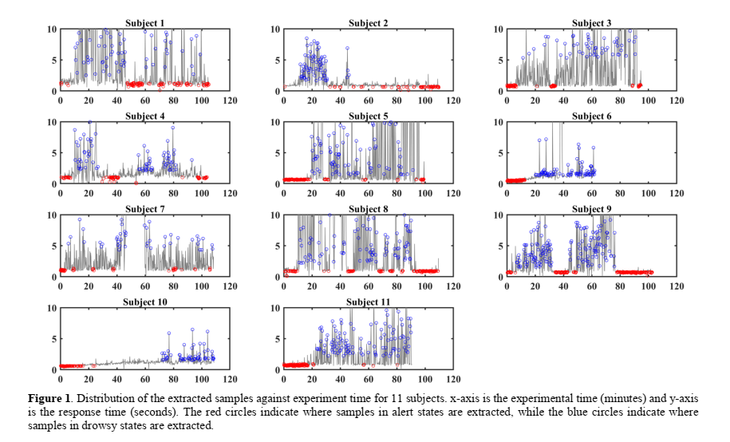

**Results and Accuracy:**

* **Model:** The proposed model is a compact CNN with a Global Average Pooling (GAP) layer.
* **Comparison Models:** The study compares the proposed model with Deep CNN and EEGNet.
* **Baseline Methods:** Conventional baseline methods include Decision Trees (DT), Random Forest (RF), K-Nearest Neighbors (KNeighbors), Gaussian Naive Bayes (GaussianNB), Linear Regression (LR), Linear Discriminant Analysis (LDA), Quadratic Discriminant Analysis (QDA), and Support Vector Machine (SVM).

**Accuracy Results:**

* + After 6 epochs, the proposed model achieves the highest average accuracy of 73.22% among the three models.
  + The average accuracy of the proposed model for each subject ranges from 67.35% to 88.25% after 6 epochs.

